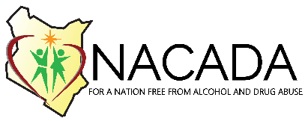
TRAINING BOOKING FORM
INDIVIDUAL BOOKING DETAILS
Participant name
Employer
Mobile number
Email address
County
Type of training
Training dates booked
Date of payment
KRA Pin Number (institution)

ORGANIZATION/GROUP BOOKING DETAILS
Name of contact person
Mobile number
Email address of contact person
Organization
County
Number of participants
Name, Telephone and email addresses of participants (Mandatory to complete booking process) | Name | Tel. No | Email address
Type of training
Training dates booked
Date of payment
KRA Pin Number (institution)
PAYMENT: Deposit the course fee in the account below:
Account Name: NACADA
Account No.: 0180296330592
Bank: Equity Bank
Bank Code: 068
Swift Code: EQBLKENA
Branch: Community
Pin: P051211631H
VAT: N/A (Appointed Agency)
Registered Office: NSSF Building
Please return complete form by email via training@nacada.go.ke
NATIONAL AUTHORITY FOR THE CAMPAIGN AGAINST ALCOHOL AND DRUG ABUSE
P.O.BOX 10774, 00100 GPO NAIROBI. NSSF BUILDING, BLOCK A, EASTERN WING, 18TH FLOOR
TELEPHONE (020)2721997/3; email ceo@nacada.go.ke

